**Real Time Whether Monitoring System**

In This project my aim is to store the Real Time Whether data into the EEPROM in every 1 minute using 8051 microcontroller. Then whenever user want they can display the data on serial monitor by clicking one button so it will display data whatever present in EEPROM and every 10-minute previous data gets erased and it will store the data from beginning.

To making this project I am using some component like temperature sensor(DS1621), LDR, Potentiometer here the DS1621 is working with I2C protocol and 8051 not having I2C and SPI protocol. So I am going for Bit Banging method to design the protocol. For Interfacing of the POT and LDR we need ADC but 8051 not having inbuilt ADC for that I used MCP3204(ADC). This IC is working in SPI protocol.so we can store in EEPROM in every 1 minute. So for time I use RTC(DS1307) which is working in I2C protocol. And I used EEPROM(AT24C08) for storing the data. All the data like Time, sensors data will print continuously on 20x4 LCD. For displaying the data from EEPROM using interrupt so when I interrupt the CPU it will go to isr for reading EEPROM and print it into serial monitor.

I am attaching the screenshot of project connection.

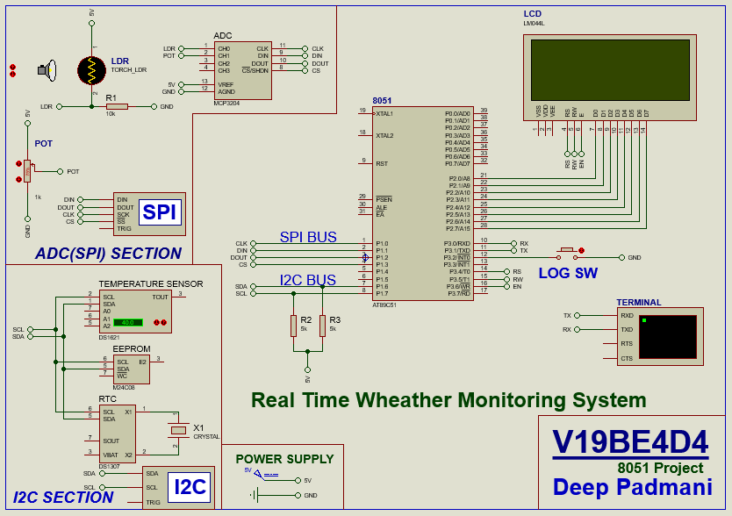

***Future Scope***

In future we can improve that application by using some extra devices like GSM.

* If user is not at a field but user need the data of last some time so user have to send one message and over system has to replay that meg in the form data. So for that we have to connect GSM instead of serial terminal.
* And also we can make one server collect that all data from EEPROM before erasing the data so there became more sufficient system.

***Project Video Link: -***

*https://drive.google.com/file/d/1VD9-aENnVYK4totleW-zG-dagTzSuGBq/view?usp=sharing*